Instagram Post Performance Analytics Dataset
A dataset containing performance metrics of Instagram posts, used for social med

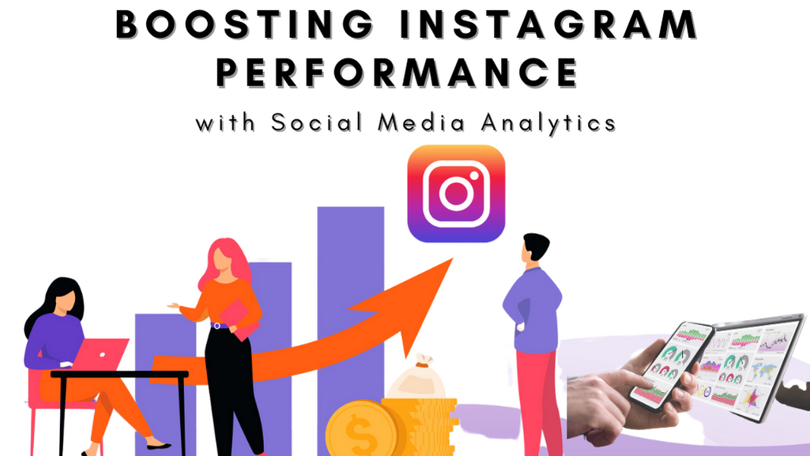

About Dataset
Content
The actual material or information being communicated. Examples: text, images, videos, messages, data, captions.
Context
The circumstances, background, or situation that gives meaning to the content. Examples: who is speaking, the purpose, the platform, the audience, timing, cultural background.

🔑 KPI 1: Total Impressions (Reach)
Formula
Total Impressions = SUM(Impressions)
Result
- 678,775 impressions
Insight
- Your content has strong overall visibility, indicating consistent posting or effective reach distribution.

🔑 KPI 2: Engagement Rate
Formula
Engagement Rate = (Likes + Comments + Shares + Saves) / Impressions
Result
- 6.02% engagement rate
Insight
- An engagement rate above 5% is considered very good for Instagram.
- Your content is resonating well with viewers, not just being seen.

🔑 KPI 3: Traffic Source Contribution
Formula
Source % = Source Impressions / Total Impressions
Result
Source | Contribution
Home | 43.4%
Hashtags | 33.1%
Explore | 18.9%
Other | 3.0%
Business Insight
- Hashtags + Explore = 52% of total reach
- This shows strong discoverability → your content is reaching new audiences, not just followers.

🔑 KPI 4: Profile Visit Rate
Formula
Profile Visit Rate = Profile Visits / Impressions
Result
- 0.89%
Insight
- Around 9 users per 1,000 impressions visit your profile.
- This suggests captions, CTAs, or visuals could be optimized to drive more curiosity.

🔑 KPI 5: Follow Conversion Rate
Formula
Follow Conversion = Follows / Profile Visits
Result
- 41%
Insight
- This is excellent 🚀
- Once users visit your profile, nearly 4 out of 10 follow you, meaning:
  - Bio
  - Highlights
  - Profile branding
are working very well.

📌 Business Analysis Questions & Answers
❓1. Which source drives the most reach?
✅ Home feed (43%), followed closely by Hashtags (33%)

❓2. Is the content discoverable to new users?
✅ Yes – Explore + Hashtags contribute over 50% of impressions.

❓3. Is engagement strong relative to reach?
✅ Yes – 6% engagement rate is above industry average.

❓4. Are profile visits converting into followers?
✅ Very effectively – 41% conversion rate indicates strong profile optimization.

❓5. Where is the biggest improvement opportunity?
📉 Profile Visit Rate (0.89%)
- Improve:
  - Caption CTAs (“Visit profile”, “Follow for more”)
  - Hook in first 2 seconds (Reels)
  - Stronger value proposition in visuals

